Requirement Management  
COMP-1787

# 

Hoàng Hưng Phát - hp9527c -001392869

University of Greenwich

Closure date

Table of Contents

Section A 4

1. Introduction about Online Groceries Online Platform 4

2. Drawbacks of Traditional Software Development Methodology 4

• Limited customer (Green Groceries/GG) involvement 5

3. Agile Frameworks Methods and its overview 5

• Aigle concepts 5

3.1 RAD 6

- RAD (Rapid Application Development) prioritizes speed and user feedback. Here's the gist: 6

• Skip lengthy planning: Start with a rough idea, refine as you go. 6

• Prototype relentlessly: Build basic models to get early user input. 6

• Feedback fuels development: Adapt features based on user insights. 6

• Polish for launch: Refine the final product for stability and delivery. 6

- This method excels at: 6

• Fast development: Get features out quickly. 6

• Adaptability: Easily adjust to changing needs. 6

• User focus: Build what users truly want. 6

3.2 Prototyping 6

6](#_Toc163728921)

3.3 Timebox approach 7

3.4 JAD 7

3.5 Sprint and Scrums 7

4. Systematic workflow of Green Groceries Online Platform done with Agile Method. 7

5. Merits of using Agile concepts 9

Section B 10

1. Base line requirements review: 10

• Given requirements analysis using MOSCOW rules (table 1) 10

• Updated high level Functional Requirement 12

2. Timebox rules for updated High Level Functional Requirement: 13

• Prioritization for the List of Requirement 13

• Explanation about prioritizing the requirement and the decisions taken for the Green Groceries Online Platform. 14

# Section A

## Introduction about Online Groceries Online Platform

Green Groceries is a medium size company specializing in providing a wide range of organic products. They have established a strong brand reputation over the past 5 year in local market. But now they plan to expand their market reach so that everyone can access sustainable products. To pursue this desire, they aim to launch an online platform within the next three months.

The problem is that they don't have their own software development team. Therefore, they need to outsource this project to a software development team with a solid reputation in the market, such as System Concepts. In the past, they've faced challenges when applying the traditional "waterfall" model to manage projects. So, after considering all possibilities, they've chosen Agile and Scrum to manage this project.

After considering the business situation, I must agree with the Managing Director's recommendation for several reasons. Firstly, the company's flexibility is crucial. It's designed to be adaptable and allows development teams to quickly change the project's scope or requirements. This is ideal for situations like this, where Green Groceries is undergoing a business structure change for the first time. Since the old process might not be suitable for the new structure, the team may need to adapt and determine the best approach as requirements evolve.

## Drawbacks of Traditional Software Development Methodology

### Limited customer (Green Groceries/GG) involvement

If we implement a traditional software development methodology like Waterfall, the Green Groceries team might only be involved in the initial stage of defining requirements. This could lead to a final product that doesn't meet the company's needs. The Agile approach offers Green Groceries the advantage of receiving frequent (mostly every two weeks) feedback on the app's progress, allowing them to confirm it matches their vision.

## Agile Frameworks Methods and its overview

### Aigle concepts

#### Agile approaches development in bite-sized pieces. These short iterations, lasting 1-4 weeks, function like mini projects.

#### Each mini project tackles all the tasks needed to deliver a small chunk of working software, including planning and requirement gathering.

#### This reduces risk by allowing for early feedback and course correction before moving on to the next stage.

#### Agile offers a toolbox of methods, including:

## RAD

## RAD (Rapid Application Development) prioritizes speed and user feedback. Here's the gist:

## Skip lengthy planning: Start with a rough idea, refine as you go.

## Prototype relentlessly: Build basic models to get early user input.

## Feedback fuels development: Adapt features based on user insights.

## Polish for launch: Refine the final product for stability and delivery.

## This method excels at:

## Fast development: Get features out quickly.

## Adaptability: Easily adjust to changing needs.

## User focus: Build what users truly want.

This emphasizes the user's role in driving the development of this new approach. This method is considered a more effective way to investigate and analyse systems, especially when traditional methods struggle.

Situation:

* Unclear Purpose: When the exact purpose or use of the system is still being figured out. (instead of "Application area is not well defined").
* New Technology: When the organization isn't familiar with the technology involved in the system. (instead of "Organization not familiar with the technology").
* Communication Breakdown: When communication between the analysts working on the system and the people who will use it hasn't been smooth. (instead of "Communication between analysts & users has not been good").

## Timebox approach

A method for creating and deploying a limited set of features for a functioning system within a fixed timeframe. (This emphasizes the prioritization and time constraint).

## JAD

JAD (Joint Application Development) directly involves clients and users in designing new information systems. This collaborative approach gathers requirements alongside development, ensuring the final product aligns closely with business needs.

## Sprint and Scrums

Scrum provides the framework, and sprints are the building blocks within that framework. A Scrum project progresses through a series of sprints, with each sprint delivering a tangible piece of the final product.

## Systematic workflow of Green Groceries Online Platform done with Agile Method.

1. Sprint 1:

* Planning:   
  **Participants**: Green Groceries’ Stake Holder, Product Owner (PO), Development Team.  
  **Agenda**:   
  - PO presents the selected backlog item that will be implement in Sprint_1.  
  - Discuss with Development team to estimate time and effort for each item.   
  - Based on priority of each item and resource, team will define story point for each item.   
  - Break down the item to smaller task and assign task for each member of development team.
* **Summary of the planning**:   
  **Key People involved**:   
  **Cheryl –** Team Leader (responsible for leading the development team, tracking team progress, and guiding the team towards achieving the sprint goal). **Millie** – Senior Developer (A skilled programmer with expertise in web development and effective communication skills).  
  **Anita** - Junior Developer.  
  **Pat** – Fresher Developer.
* **Key module of Sprint 1**: Order Tracking

* How it works:
* The system interacts with two external entities: customers and a back-end system.
* Customers can interact with the system through a front-end which allows them to select products (view, add, edit, delete from cart), and place orders.
* Once an order is placed, the system sends the order data to the back-end system, which likely houses a database.
* The front-end also allows customers to check on the status of their orders. To do this, the system queries the database for order data that matches the user.
* The back-end system can also send data back to the front-end, presumable to update the order status for the customer.

1. Sprint 2:

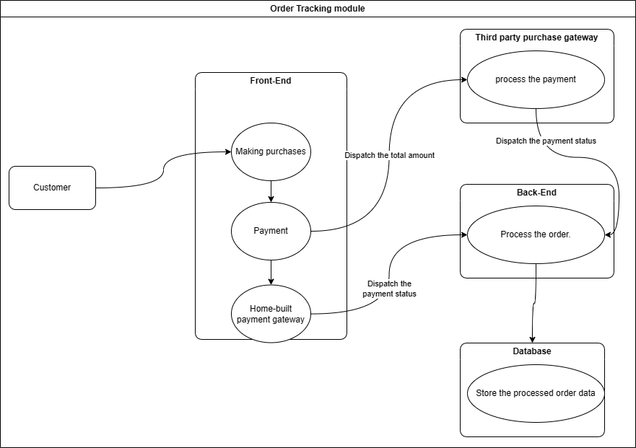

1. Sprint 3:

1. Sprint 4:

## Merits of using Agile concepts

**Faster Feedback and Adaptability**: Agile prioritizes short iterations (sprints) with frequent feedback loops. This allows teams to adjust course quickly based on user feedback and changing requirements. It reduces the risk of building features that nobody wants or needs.

**Improved Customer Satisfaction**: By actively involving stakeholders and users throughout the development process, Agile ensures the final product aligns closely with their needs and expectations. Early and continuous feedback helps deliver a product that offers real value to the customer.

**Enhanced Team Collaboration**: Agile fosters a collaborative environment where developers, testers, and stakeholders work together as a team. This reduces communication silos, fosters a sense of ownership, and ultimately leads to a more cohesive development process.

**Reduced Risk and Increased Predictability**: Breaking down projects into smaller, manageable sprints makes it easier to identify and mitigate risks early on. Additionally, the focus on delivering working features in short cycles provides greater predictability in terms of timelines and deliverables.

**Increased Efficiency and Productivity**: Agile emphasizes a streamlined and focused development process. By prioritizing critical functionalities and eliminating unnecessary tasks, teams can work more efficiently and deliver value faster.

# Section B

High level requirements analysis using MOSCOW rules:

## Base line requirements review:

### Given requirements analysis using MOSCOW rules (table 1)

|  |  |  |  |
| --- | --- | --- | --- |
| **ID** | **Requirements List** | **MOSCOW Rules Applied** | **Reasons** |
| **1** | As an Order Handling Clerk, I want to use the website to process telephone purchases, replacing the paper-based system. | Must Have | This is a core functionality that replaces an existing manual process, improving efficiency. |
| **2** | Maintain at least 20 office plants as part of the company's commitment to a green and healthy workspace. | Won't Have This Time | While desirable, it's not directly related to the website functionality and can be addressed outside the project scope. |
| **3** | As a customer, I want to be able to change my account details to ensure my most up-to-date information is recorded. (duplicate) | Should Have | User account management is essential for customer relationship management (CRM). |
| **4** | Organize a virtual celebration on the website for the CEO's birthday to showcase the company's fun and friendly culture. | Could Have | While it promotes company culture, it's not critical website functionality. |
| **5** | As the Managing Director I want to be ensured that the site is Data Protection Act safe so that we do not get fined hundreds of thousands of pounds. | Must Have | Compliance with data protection regulations is essential to avoid legal and financial repercussions. |
| **6** | As a customer register an account. | Must Have | User accounts are necessary for many functionalities like order history and tracking. |
| **7** | As a Customer I want a choice of delivery slots so that I can arrange my diary appropriately. | Should Have | Delivery flexibility is a key customer expectation for online shopping. |
| **8** | As a customer, I want to be able to modify my shopping cart so that I can change my mind about what I want to buy. | Must Have | The ability to edit the cart is essential for a smooth shopping experience. |
| **9** | The company should adopt pet-friendly policies to create a positive and inclusive work environment. | Won't Have This Time | Like maintaining plants, it's outside the website's scope. |
| **10** | The system must be designed to handle a 30% increase in traffic during peak periods without degradation in performance. | Must Have | Scalability is crucial to ensure site stability during high traffic times. |
| **11** | As a customer, I want to enter separate delivery and invoice addresses so that I can receive bags when staying at a friend's house. | Should Have | Providing separate addresses enhances customer convenience. |
| **12** | As a customer, I want to choose whether or not I am sent marketing information to avoid receiving excessive junk mail. | Could Have | While valuable for customer preference, it's not essential for core website functionality. |
| **13** | All user data, including personal information and payment details, must be encrypted to ensure the highest level of security. | Must Have | Data security is paramount to protect user information and avoid security breaches. |
| **14** | Maintain consistent branding elements and design across the website to reinforce their brand identity. | Should Have | Brand consistency enhances user experience and professionalism. |
| **15** | The development team should participate in a team-building event every quarter to foster collaboration and a positive work environment. | Won't Have This Time | This is an internal team development activity that can be addressed outside the project. |
| **16** | As the Marketing Director I would like an offers or discount page so that we can inform our customers of the aforementioned. | Should Have | Promotional tools are important for customer engagement and sales. |
| **17** | As the Chief Accountant I want to the Web site to adhere to legislation regarding VAT so we are not hit with a hefty fine. | Must Have | Compliance with VAT regulations is essential to avoid financial penalties. |
| **18** | As the Operations Director, I want to accept all forms of payment to capture the largest market possible. | Should Have | Offering multiple payment options caters to diverse customer preferences and increases sales potential. |

### Updated high level Functional Requirement

|  |  |  |
| --- | --- | --- |
| **ID** | **Updated High Level Functional Requirements** | **Justifications/ Recommendations** |
| 19 | As a mobile shopper, I want the website to display well on my phone so that I can browse and purchase products easily. | Ensures a smooth user experience on all devices and avoids losing mobile shoppers. |
| 20 | As a customer, I want to find the category or product I'm looking for quickly using clear navigation menus so that I can save time and effort. | Helps customers find products quickly and efficiently, leading to higher satisfaction. |
| 21 | As a visitor considering a purchase, I want the website to load quickly so that I'm not frustrated and abandon my shopping cart. | Reduces cart abandonment and improves overall user experience. |
| 22 | As a shopper, I want to see detailed product descriptions and high-quality images so that I can make informed purchasing decisions | Enables informed purchase decisions and reduces customer inquiries and returns. |
| 23 | As a customer making a purchase, I want to use a secure payment gateway to enter my financial information with confidence. | Builds trust with customers and encourages them to complete transactions. |
| 24 | As a customer ready to check out, I want a streamlined process with minimal steps so that I can complete my purchase quickly and easily. | Reduces friction and encourages customers to finalize their purchases. |
| 25 | As a customer looking for a specific product, I want to use a search bar with filters and suggestions to find what I need efficiently. | Saves customers time and improves product discovery, especially on large sites. |
| 26 | As a customer considering a product, I want to read reviews and ratings from other customers to help me decide on a purchase. | Builds trust and influences buying decisions through social proof. |
| 27 | As a registered user, I want to track my order status and manage my account information so that I can stay informed and personalize my shopping experience. | Enhances customer experience by providing control and transparency over purchases. |

## Timebox rules for updated High Level Functional Requirement:



### Prioritization for the List of Requirement

|  |  |  |  |
| --- | --- | --- | --- |
| **ID** | **Updated high level functional requirements** | **Priority Levels (High or Moderate or Low)** | **Time scale** |
| 19 | As a mobile shopper, I want the website to display well on my phone so that I can browse and purchase products easily. | High priority | 2- 3 days |
| 20 | As a customer, I want to find the category or product I'm looking for quickly using clear navigation menus so that I can save time and effort. | High priority | 1-2 days |
| 21 | As a visitor considering a purchase, I want the website to load quickly so that I'm not frustrated and abandon my shopping cart. | High priority | 3-4 days |
| 23 | As a customer making a purchase, I want to use a secure payment gateway to enter my financial information with confidence. | High priority | 1-2 days |
| 24 | As a customer ready to check out, I want a streamlined process with minimal steps so that I can complete my purchase quickly and easily. | High priority | 1-2 days |
| 27 | As a registered user, I want to track my order status and manage my account information so that I can stay informed and personalize my shopping experience. | High priority | 1-2 days |
| 22 | As a shopper, I want to see detailed product descriptions and high-quality images so that I can make informed purchasing decisions | Moderate priority | 1-2 days |
| 25 | As a customer looking for a specific product, I want to use a search bar with filters and suggestions to find what I need efficiently. | Moderate priority | 2-3 days |
| 26 | As a customer considering a product, I want to read reviews and ratings from other customers to help me decide on a purchase. | Low priority | Later |

### Explanation about prioritizing the requirement and the decisions taken for the Green Groceries Online Platform.

There are several factors that I considered when prioritizing the requirements for the Green Groceries Online Platform:

* Business value: How important is the feature to enabling essential features and boosting revenue?
* User impact: Does the feature have an immediate effect on how satisfied and how the user feels?
* Development Complexity: How much resources, time, and effort are needed to develop the feature?
* Dependencies: Are there any features that need to be finished before moving on to another feature?